User Manual Specification
Release Version -1.1
For
Meghna Solar Ltd.
Concern Topic: Report management

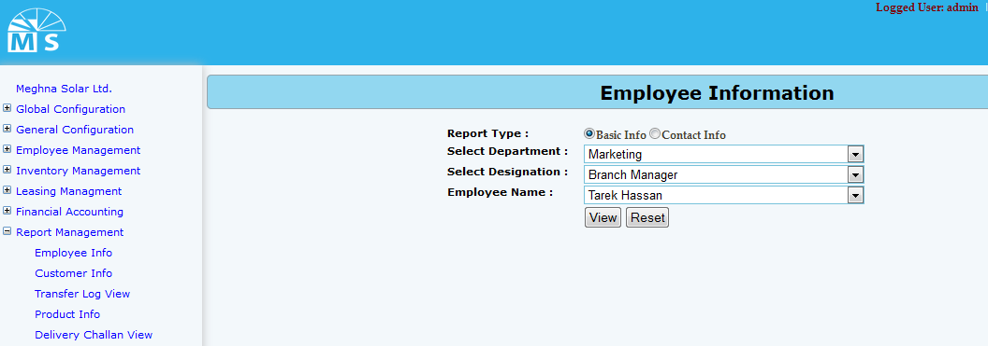

Employee info Report (Basic info)

For emoployee info report there are two option. User can see Employee basic info or employee contact info. For basic info report user can directly click on view or may select department, designation and name for specific group or person’s report.
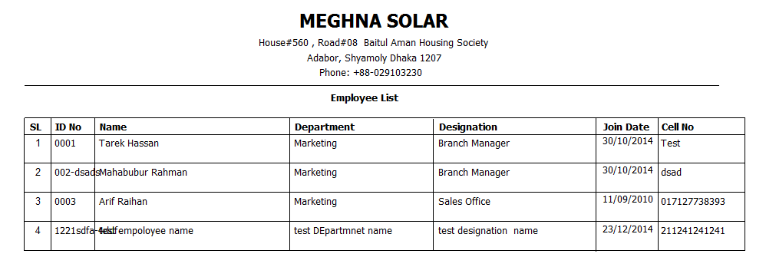

Employee Basic Info Report

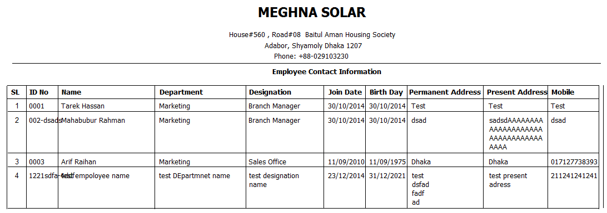
Employee Contact Info report

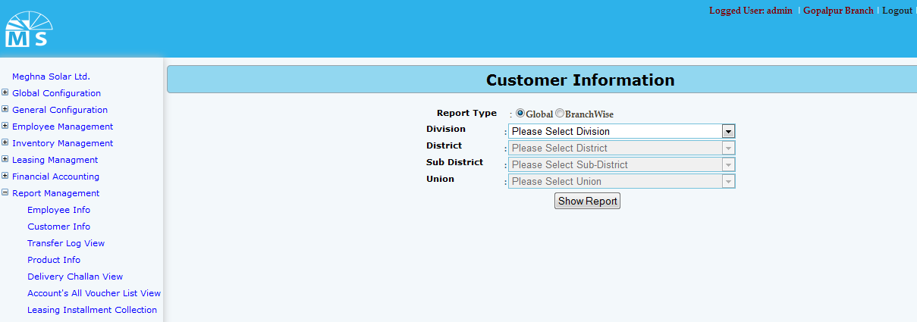
Customer information report

For Customer information report there are two option. User can see Global info or Branch wise info. For Global info report user can directly click on Show report button or may select division, district, sub district and union for specific group or customer report.

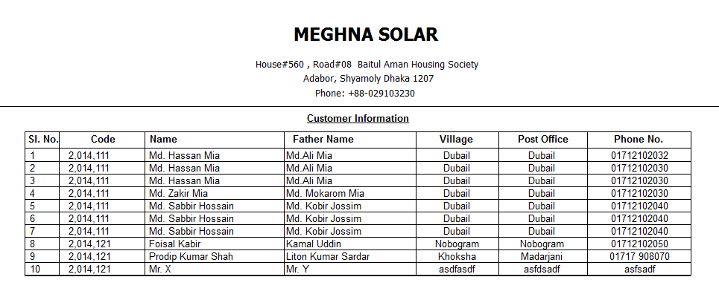
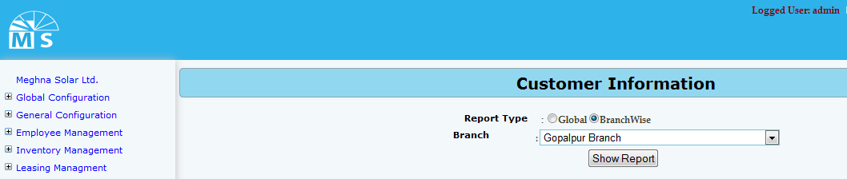
Global information report
Customer information report (branch wise)

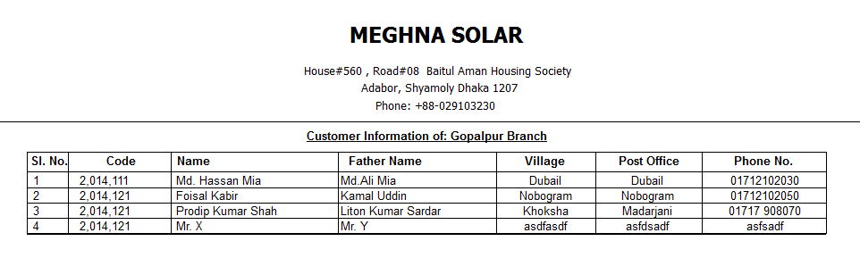
Customer info report branch wise
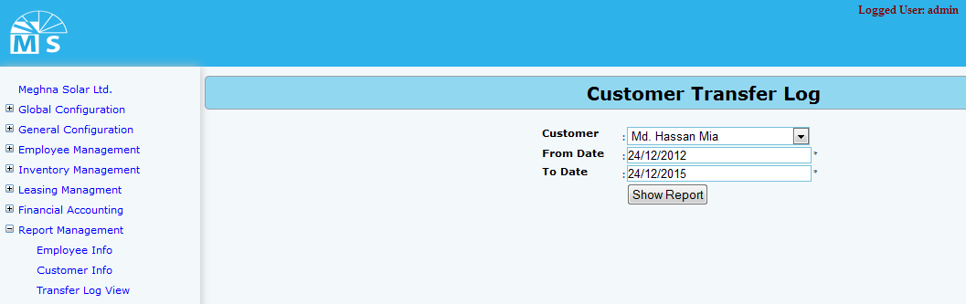
Customer transfer log Report
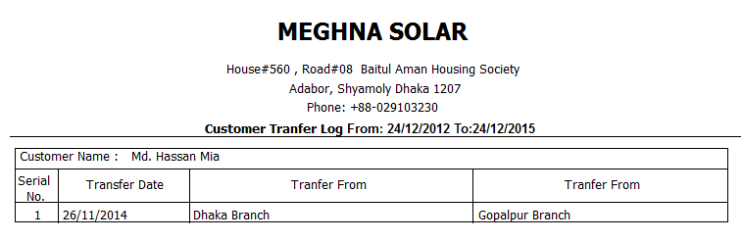
Customer transfer log report

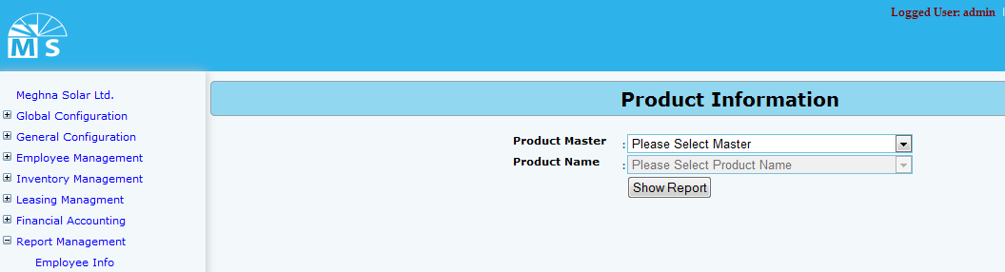
Product information report page

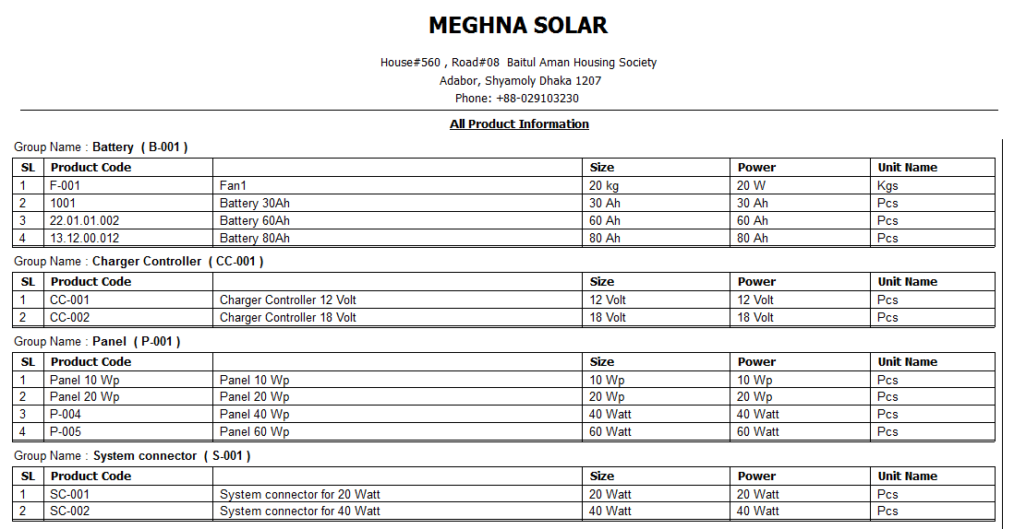
Product information report
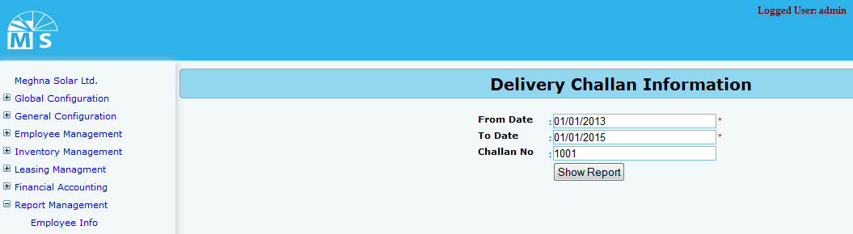
Delivery Challan view report page
In Delivery Challan view report page user can view report by inserting from date and to date. Moreover for specific challan user can enter challan no and click show report button to see the report of that challan information.

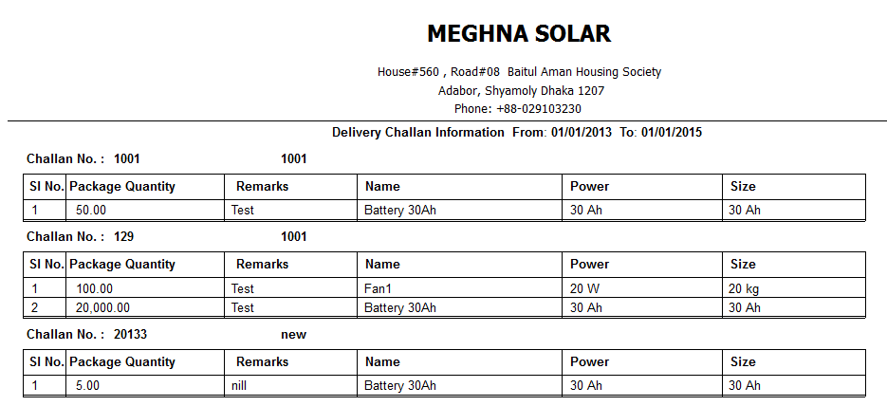
Delivery challan view entry report

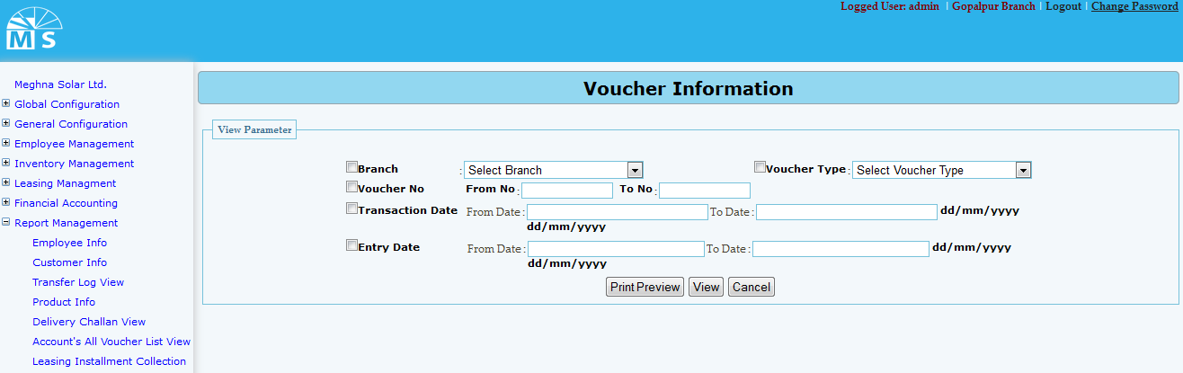
Voucher information report page
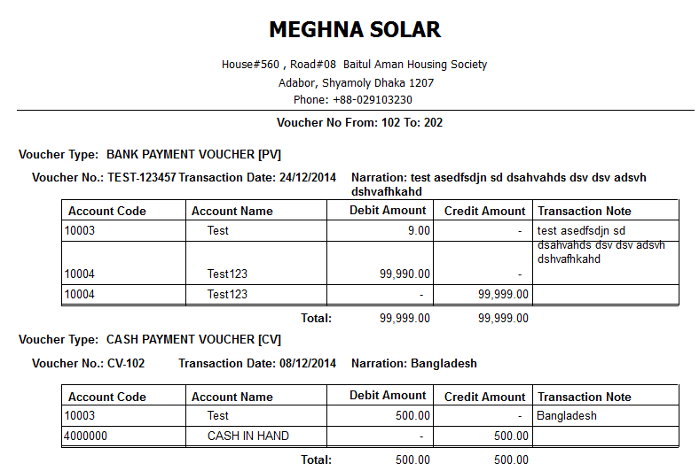
Voucher information report
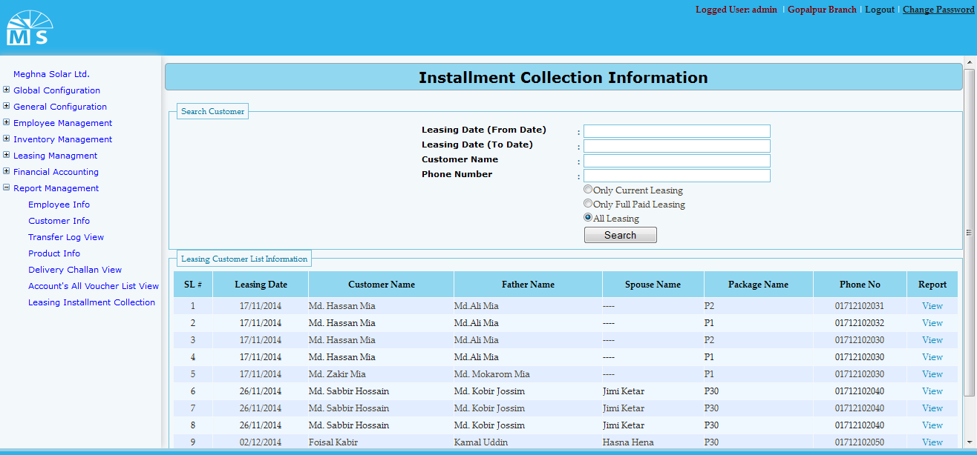
Leasing installment collection report page

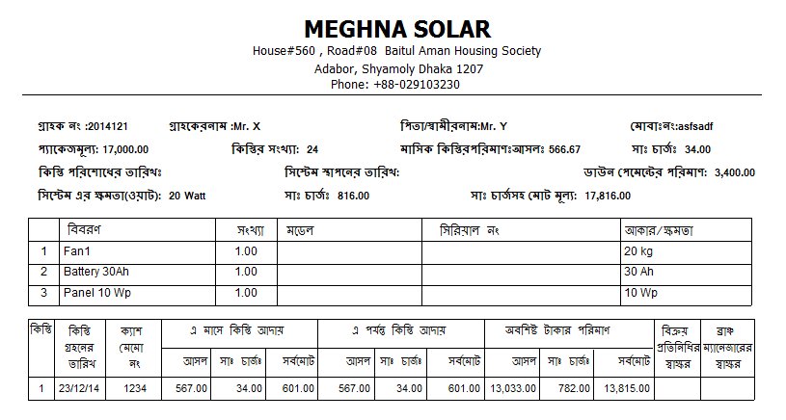
Leasing installment collection report

